**Array Programs -**

1 - Taking Input in array. Sum, Mul, & Avg of an aray

2 - Find Min, Max & Any particular element in array

3 - Find element at any indexing, 1st index element, last index element

4 - Find Frequqency of any element in Array

5 - Reverse & Sorting of an array

6 - Max & Min using Sorting, K-max & K-Min using Sorting

7 - Targeted Element. Print yes if there is a pair in the array that sum up to target. Array ke kisi element ya kinhi bhi elements ka sum target ke brabr he to yes kre

8 -For given 2 arrays, find Union & Intersection

9 - Find majority element if any.

10 - Array Rotation - Left, Right, K-times

11 - Subarray : - If target found using subarray sum then put yes otherwise leave it with no.

**Arrays in CPP –**

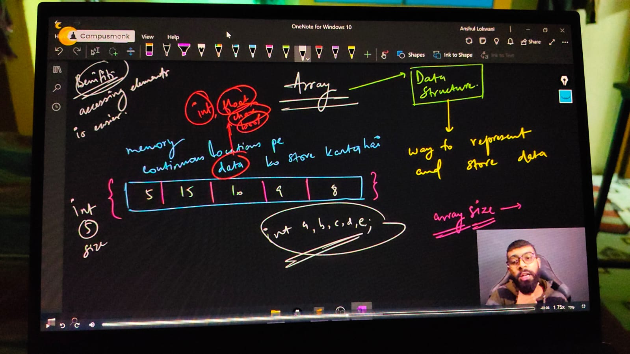

Array indexing concewpt –

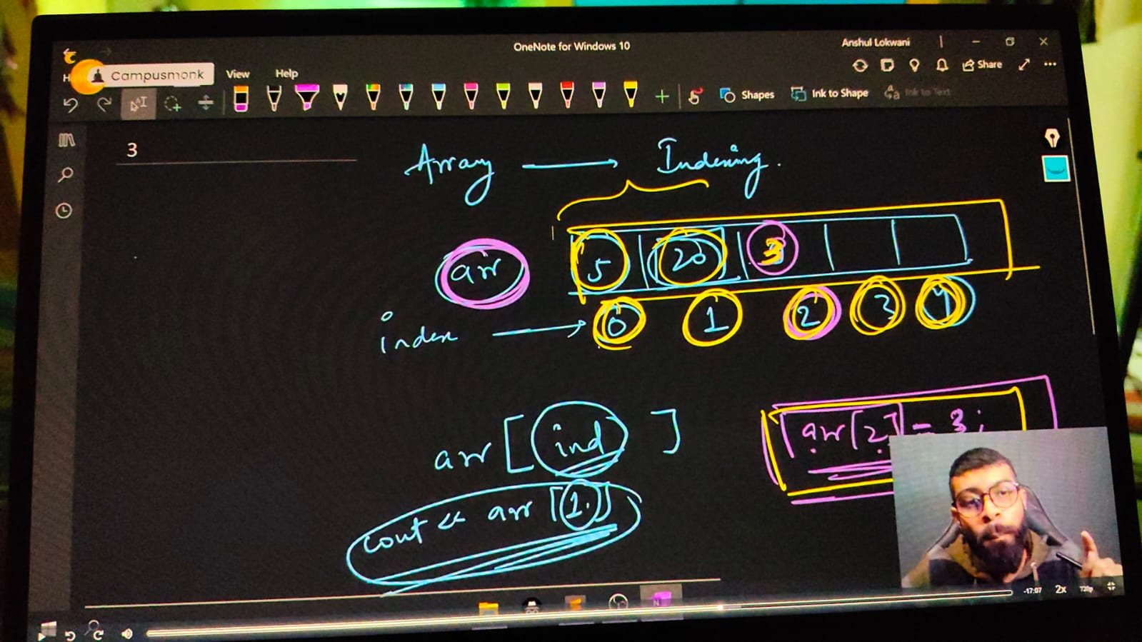

#include<iostream>

using namespace std;

int main()

{

    // Array in CPP -

    // Array declaration and array syntax -

    // DATATYPE ARRAY_NAME [Size]

    int arr[5];

    // initialization of an array -

    int arrr[6] = {6,5,4,3,2,1};

    // array printing

    /*

    cout<<arrr[0]<<endl;//6

    cout<<arrr[1]<<endl;//5

    cout<<arrr[2]<<endl;//4

    cout<<arrr[3]<<endl;//3

    cout<<arrr[4]<<endl;//2

    cout<<arrr[5]<<endl;//1

    cout<<arrr[6]<<endl;//6422280 - error as memory not specified so any bvalue produces toa avpid error

    */

    for (int i = 0; i <= 5; i++)

    {

        cout<<arrr[i]<<endl;

// ____________ ____________

**// Taking input for array size**

    // int size; cout<<"mrntion the size of arry you want to take for elements"<<endl; cin>>size;

    // int arey[size];

    // cout<<"Now enter the array values one by one"<<endl;

    // for (int j = 0; j < size; j++)

    // {

    //     cin>>arey[j];

    // }

    // cout<<"You entered array values as following - "<<endl;

    // for (int j = 0; j < size; j++)

    // {

    //     cout<<arey[j]<<endl;

    // }

// ____________ ____________

**// sun of array's elements**

    // int sum=0;

    // int aruy[5] = {10,20,30,40,50};

    // for (int k = 0; k < 5; k++)

    // {

    //     sum=sum+aruy[k];

    // }

    // cout<<sum<<endl;

    // ____________ ____________

**// Mltiplication of all elenewntds of an array**

    // int product=1;

    // int aruyy[5] = {10,20,30,40,50};

    // for (int k = 0; k < 5; k++)

    // {

    //     product=product*aruyy[k];

    // }

    // cout<<"So the multiplication result is - "<<product<<endl;

// ____________ ____________

**// Avg of an array**

    // int avg=0,summ=0;

    // int aruyyy[5] = {10,20,30,40,50};

    // for (int k = 0; k < 5; k++)

    // {

    //     summ=summ+aruyyy[k];

    //     avg = sum/5;

    // }

    // cout<<"So the sum  is - " <<summ<<" and the avg is - "<<avg<<endl;

// ____________ ____________

**// Now usign this sum/Ml/Avg printing approach by taking input from the user manualy**

    // int size;

    // cout<<"Enter the size of array you wwant"<<endl;

    // cin>>size;

    // int arrey[size];

    // cout<<"It's  time to enter the values of your array dude"<<endl;

    // for (int i = 0; i < size; i++)

    // {

    //     cin>>arrey[i];

    // }

    // cout<<"So the insereted eleemnts are - "<<endl;

    // for (int j = 0; j < size; j++)

    // {

    //     cout<<arrey[j]<<endl;

    // }

    // int totalsum=0, mul=1,avgg=0;

    // for (int k = 0; k < size; k++)

    // {

    //     totalsum = totalsum+arrey[k];

    //     mul=mul*arrey[k];

    //     avgg = float(totalsum/size);

    // }

    // cout<<" The sum of inserted elements is "<<totalsum<<endl;

    // cout<<" So the multiplication result is - "<<mul<<endl;

    // cout<<" and the most epic avg of elements is "<<avgg<<endl;

// ____________ ____________ ____________ ____________ ____________

// Array Basic QUnstions -

**// 1) - Min. Element from Array**

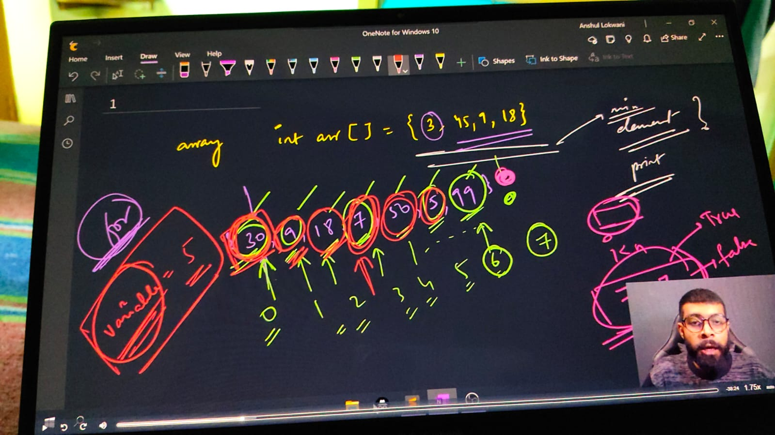

// int n;

    // cout << "ENtert no. of elements in your array " << endl;

    // cin >> n;

    // int arr1[n];

    // cout<<"Enter elements of an array - "<<endl;

    // for (int i = 0; i < n; i++)

    // {

    //     cin >> arr1[i];//15,2,89,75,63

    // }

    // // for min. element among all

    // int minelmnt = arr1[0];

    // for (int i = 0; i < n; i++)

    // {

    //     if (arr1[i] < minelmnt)

    //     {

    //         minelmnt = arr1[i];

    //     }

    // }

    // cout << "Min element among this is - " << minelmnt << endl;// - 2

// ____________ ____________ ____________ ____________ ____________

**// 2) - Max. Element from array -**

    // int n;

    // cout << "ENtert no. of elements in your array " << endl;

    // cin >> n;

    // int arr2[n];

    // for (int i = 0; i < n; i++)

    // {

    //     cin >> arr2[i];//15,2,89,75,63

    // }

    // // Max eleemnt  -

    // int maxelemnt = arr2[0];

    // for (int i = 0; i < n; i++)

    // {

    //     if (arr2[i] > maxelemnt)

    //     {

    //         maxelemnt = arr2[i];

    //     }

    // }

    // cout << "Maximum element is - " << maxelemnt << endl;// - 89

    // These two quns were about aRRAY traverse or array iterate

// ____________ ____________ ____________ ____________ ____________

**// 3) FInd any element present in the array or not**

    // int n;

    // cout << "ENtert no. of elements in your array " << endl;

    // cin >> n;

    // int arr1[n];

    // for (int i = 0; i < n; i++)

    // {

    //     cout<<"Enter the "<<i<<" element value "<<endl;

    //     cin >> arr1[i];

    // }

    // // Find ELement  -

    // int searchingelement = 50;

    // // cout<<"Enter the elemnt you want to search"<<endl;

    // // cin>>searchingelement;

    // for (int i = 0; i < n; i++)

    // {

    //     if (arr1[i] == searchingelement)

    //     {

    //         cout<<"Element "<<searchingelement<<" found successfully at indexing "<<i<<endl;

    //         return 0;

    //     }

    // }

    // cout<<"Sorry Beaste, Elment you wewre looking for din't found"<<endl;

// ____________ ____________ ____________ ____________ ____________

**// 4) FInd elemnt at which indexing -**

    // int n; cout<<"What is the size of an array"<<endl;

    // cin>>n;

    // int arru[n];

    // cout<<"Give the array elementts"<<endl;

    // for (int i = 0; i < n; i++)

    // {

    //     cin>>arru[i];

    // }

    // int x; cout<<"x you wnat to search for "<<endl;

    // cin>>x;

    // for (int i = n-1; i >= 0; i--) //or for(int i=0; i<n; i++) - its just another ways for iterating inside an array

    // {

    //     if (arru[i] == x)

    //     {

    //         cout<<"found at indexing "<<i<<endl; // If element exist multiple times it'll give indexing for each time

    //     }

    // }

    // return -1;

// ____________ ____________

**// 4.1) Find FIrst index of element searched**

    // int n; cout<<"What is the size of an array"<<endl;

    // cin>>n;

    // int arru[n];

    // cout<<"Give the array elementts"<<endl;

    // for (int i = 0; i < n; i++)

    // {

    //     cin>>arru[i];

    // }

    // int x; cout<<"x you wnat to search for "<<endl;

    // cin>>x;

    // for(int i=0; i<n; i++) //or  - for getting the indexing from last

    // {

    //     if (arru[i] == x)

    //     {

    //         cout<<"found at indexing "<<i<<endl; // If element exist multiple times it'll give only for the first indexing as we programmed

    //         return 0;

    //     }

    // }

    // return -1;

/*

O/p -

What is the size of an array

5

Give the array elementts

89

45

89

78

23

x you wnat to search for

89

found at indexing 0

*/

// ____________ ____________

**// 4.2) Find last index of element searched**

    // int n; cout<<"What is the size of an array"<<endl;

    // cin>>n;

    // int arru[n];

    // cout<<"Give the array elementts"<<endl;

    // for (int i = 0; i < n; i++)

    // {

    //     cin>>arru[i];

    // }

    // int x; cout<<"x you wnat to search for "<<endl;

    // cin>>x;

    // for (int i = n-1; i >= 0; i--) // for getting the indexing from last

    // {

    //     if (arru[i] == x)

    //     {

    //         cout<<"found at indexing "<<i<<endl; // If element exist multiple times it'll give only for the first indexing as we programmed

    //         return 0;

    //     }

    // }

    // return -1;

/*

O/p -

What is the size of an array

5

Give the array elementts

89

45

89

78

23

x you wnat to search for

89

found at indexing 2

*/

**// OR METHOD 2 - MAIN METHOD**

// int n; cout<<"What is the size of an array"<<endl;

//     cin>>n;

//     int arru[n];

//     cout<<"Give the array elementts"<<endl;

//     for (int i = 0; i < n; i++)

//     {

//         cin>>arru[i];

//     }

//     int x; cout<<"x you wnat to search for "<<endl;

//     cin>>x;

//     int index = -1;

//     for(int i=0; i<n; i++)

//     {

//         if (arru[i] == x)

//         {

//             index = i; // For getting indexing from last updating

//         }

//     }

//     cout<<index<<endl;

/*

What is the size of an array

5

Give the array elementts

89

45

89

78

89

x you wnat to search for

89

4

*/

// ____________ ____________ ____________ ____________ ____________

**// 5) Find Frequency of x in array - howe many times any element is repeating**

int n; cout<<"What is the size of an array"<<endl;

cin>>n;

int arru[n];

cout<<"Give the array elementts"<<endl;

for (int i = 0; i < n; i++)

{

    cin>>arru[i];

}

int x; cout<<"x you wnat to search for "<<endl;

cin>>x;

int gotit=0;

for(int i=0; i<n; i++)

{

    if (arru[i] == x)

    {

        gotit++;

    }

}

cout<<"frequency of element is - "<<gotit<<endl;

/*

What is the size of an array

5

Give the array elementts

89

78

89

45

89

x you wnat to search for

89

frequency of element is - 3

*/

**Reverse and Sorting of an Array**

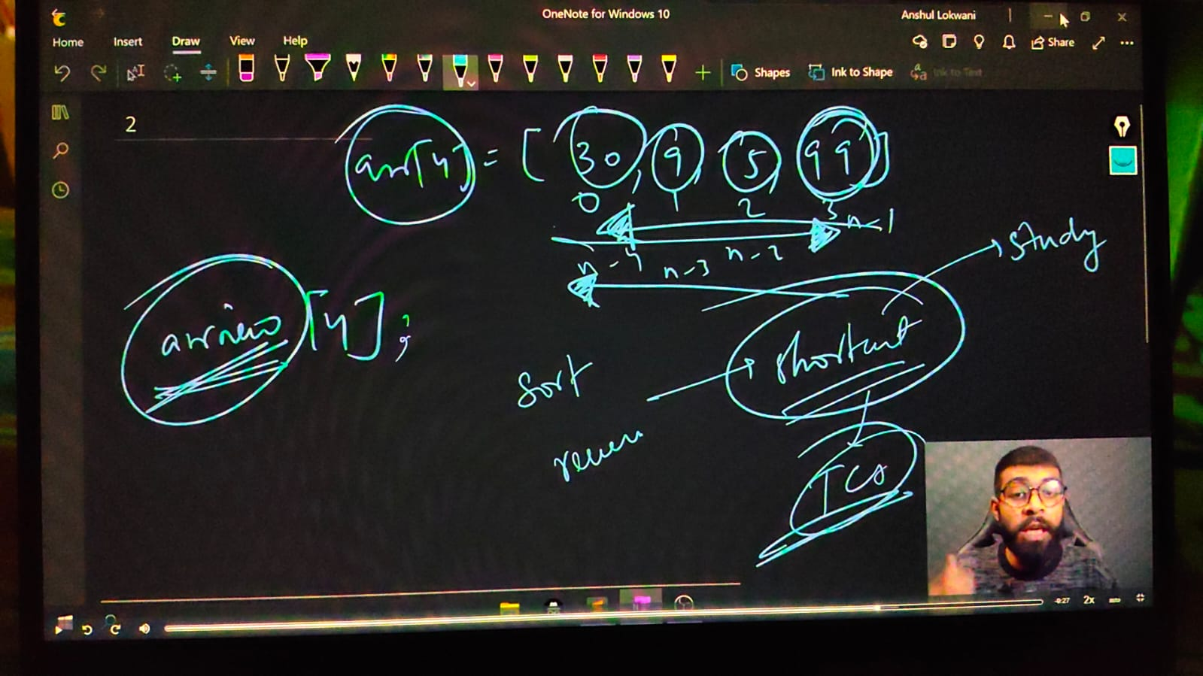

// For reversing an array we must include a header file named as algorithms

    int n; cout<<"What is the size of an array"<<endl;

    cin>>n;

    int arru[n];

    cout<<"Give the array elementts"<<endl;

    for (int i = 0; i < n; i++)

    {

        cin>>arru[i];

    }

    // For Reverseing an array -

    // Syntax for reverse - reverse(ARRAYNAME, ARRAYNAME+ARRAYSIZE)

    // Modified syntax as per trials - reverse(ARRAYNAME+jaha tk reverse krna ho, ARRAYNAME+jaha se reverse krna ho)

    // reverse(arru, arru+n);

    // for (int i = 0; i < n; i++)

    // {

    //     cout<<arru[i]<<" ";

    // }

/*

What is the size of an array

5

Give the array elementts

15

89

23

78

56

56 78 23 89 15

*/

// ____________ ____________ ____________ ____________ ____________

**// 6.1) For sorting an array -**

// Syntax for sort - sort(ARRAYNAME, ARRAYNAME+ARRAYSIZE)

// Modified syntax as per trials - sort(ARRAYNAME+jaha tk sort krna ho, ARRAYNAME+jaha se sort krna ho)

// sort(arru, arru+n);

// for (int i = 0; i < n; i++)

// {

//     cout<<arru[i]<<" ";

// }

/*

What is the size of an array

5

Give the array elementts

89

78

56

21

45

21 45 56 78 89

*/

// ____________ ____________

//  for sorting in decreasing order. First sort then usereverse

// sort(arru, arru+n);

// reverse(arru, arru+n);

// for (int i = 0; i < n; i++)

// {

//     cout<<arru[i]<<" ";

// }

/*

What is the size of an array

5

Give the array elementts

45

98

100

20

78

100 98 78 45 20

*/

// ____________ ____________

**// Min & Max using Sort in Array -**

// sort(arru, arru+n);

// for (int i = 0; i < n; i++)

// {

//     cout<<arru[i]<<" ";

// }

// cout<<endl;

// cout<<"Min is  "<<arru[0]<<endl;

// cout<<"MaX is  "<<arru[n-1]<<endl;

/*

What is the size of an array

5

Give the array elementts

89

32

56

12

47

12 32 47 56 89

Min is  12

MaX is  89

*/

// ____________ ____________

**//  Find kth Max & Kth Min in Array -**

// sort(arru, arru+n);

// int k;

// cout<<"Which max or min element you want to get"<<endl;

// cin>>k;

// sort(arru, arru+n);

// for (int i = 0; i < n; i++)

// {

//     cout<<arru[i]<<" ";

// }

// cout<<endl;

// cout<<k<<"th Minimun element is "<<arru[k-1]<<endl;

// cout<<k<<"th Maximum element is "<<arru[n-k]<<endl;

/*

What is the size of an array

5

Give the array elementts

12

56

78

32

99

Which max or min element you want to get

2

12 32 56 78 99

2th Minimun element is 32

2th Maximum element is 78

*/

**// What if the Interviewer yold that you can;t use Sort or inbuilt library functions. Method 2 for kth Min & kth Max –**

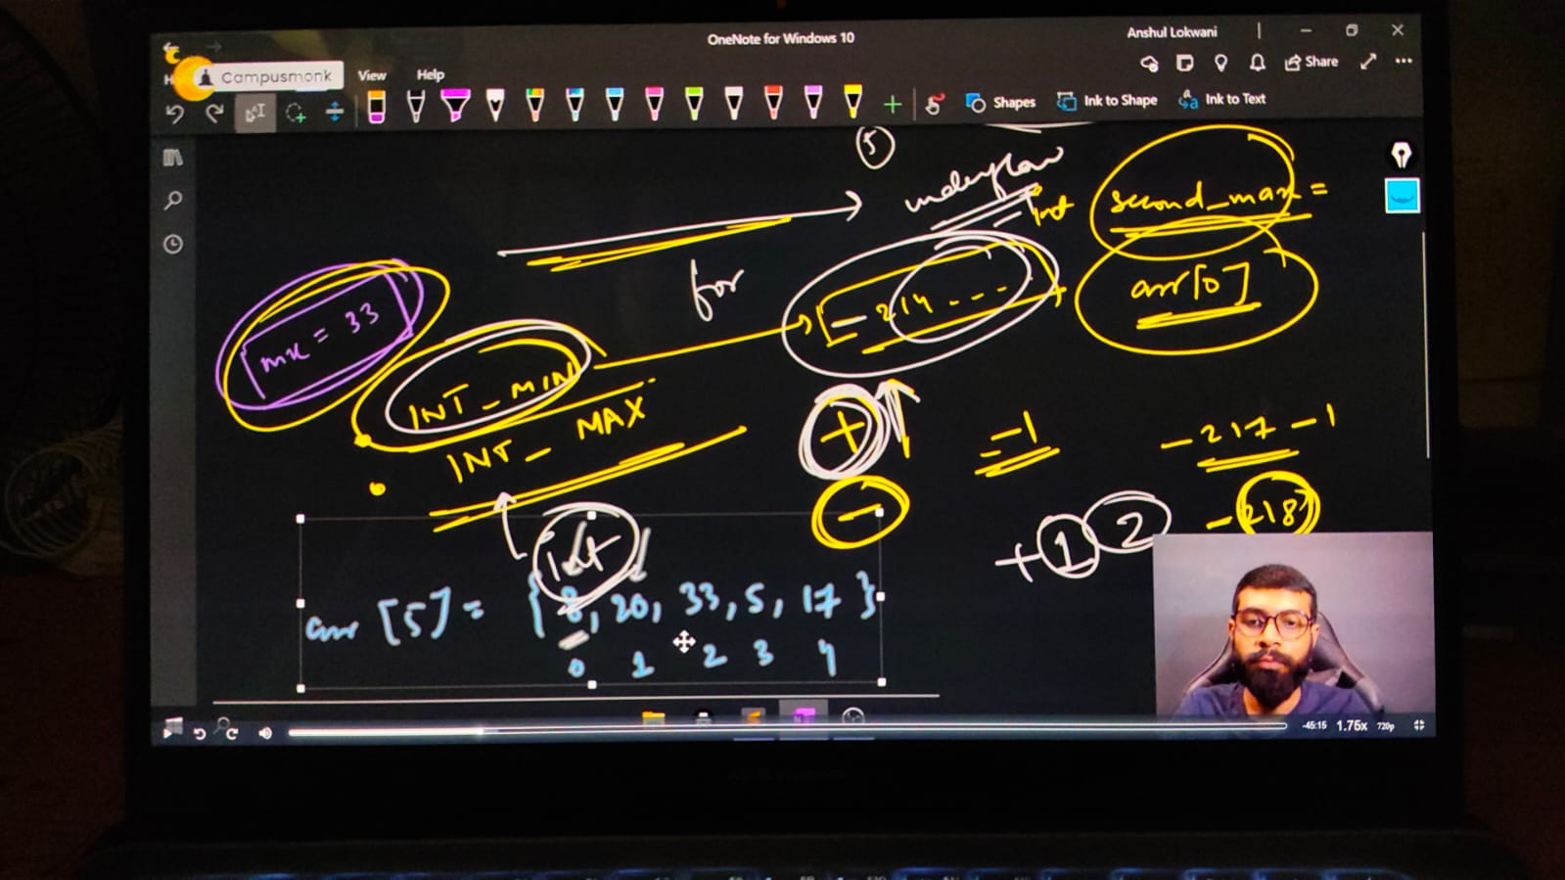

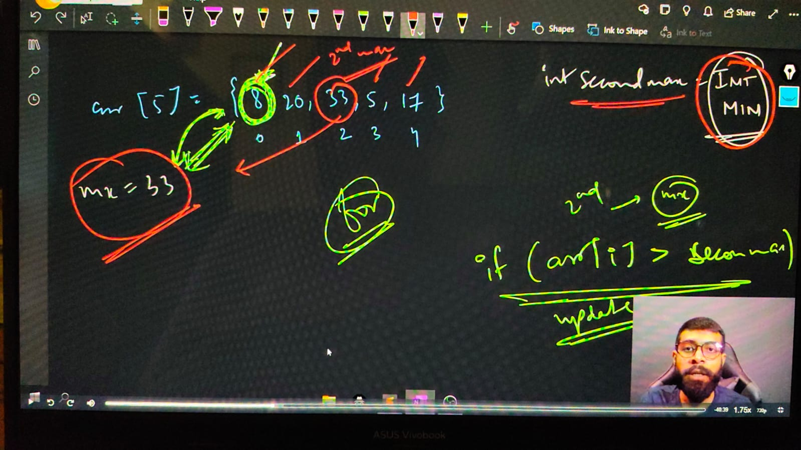

**// For the 2nd max fun**

    // int n;

    // cout<<"Mention the size of an array"<<endl;

    // cin>>n;

    // int arr[n];

    // cout<<"Insrt the array elements - "<<endl;

    // for (int i = 0; i < n; i++)

    // {

    //     cin>>arr[i];

    // }

    // cout<<"So, the entered array is - "<<endl;

    // for (int i = 0; i < n; i++)

    // {

    //     cout << arr[i] <<" ";

    // }

    // cout<<endl;

    // // For the first max

    // int mx = arr[0];

    // for (int i = 0; i < n; i++)

    // {

    //     if (arr[i]>mx)

    //     {

    //         mx=arr[i];

    //     }

    // }

    // cout<<"The Maximuum element is "<<mx<<endl;

    // // For the second max

    // int secondmax = INT_max;

    // for (int i = 0; i < n; i++)

    // {

    //     if (arr[i] != mx)

    //     {

    //         if (arr[i]>secondmax)

    //         {

    //             secondmax = arr[i];

    //         }

    //     }

    // }

    // cout<<"So, the second max element is - "<<secondmax<<endl;

/*

Mention the size of an array

5

Insrt the array elements -

78

89

56

12

23

So, the entered array is -

78 89 56 12 23

The Maximuum element is 89

So, the second max element is - 78

*/

// ____________ ____________

**// For the 2nd max -**

    // int n;

//     cout<<"Mention the size of an array"<<endl;

//     cin>>n;

//     int arr[n];

//     cout<<"Insrt the array elements - "<<endl;

//     for (int i = 0; i < n; i++)

//     {

//         cin>>arr[i];

//     }

//     cout<<"So, the entered array is - "<<endl;

//     for (int i = 0; i < n; i++)

//     {

//         cout << arr[i] <<" ";

//     }

//     cout<<endl;

//     // For the first max

//     int max = arr[0];

//     for (int i = 0; i < n; i++)

//     {

//         if (arr[i]<max)

//         {

//             max=arr[i];

//         }

//     }

//     cout<<"The maximum element is "<<max<<endl;

//     // For the second max

//     int secondmax = INT_MAX;

//     for (int i = 0; i < n; i++)

//     {

//         if (arr[i] != max)

//         {

//             if (arr[i]<secondmax)

//             {

//                 secondmax = arr[i];

//             }

//         }

//     }

//     cout<<"So, the second max element is - "<<secondmax<<endl;

/*

Mention the size of an array

5

Insrt the array elements -

78

89

56

12

23

So, the entered array is -

78 89 56 12 23

The maximum element is 12

So, the second max element is - 23

*/

// ____________ ____________ ____________ ____________ ____________

**// Similarly for 3rd Max**

int n;

    cout<<"Mention the size of an array"<<endl;

    cin>>n;

    int arr[n];

    cout<<"Insrt the array elements - "<<endl;

    for (int i = 0; i < n; i++)

    {

        cin>>arr[i];

    }

    cout<<"So, the entered array is - "<<endl;

    for (int i = 0; i < n; i++)

    {

        cout << arr[i] <<" ";

    }

    cout<<endl;

    // For the first max

    int max = arr[0];

    for (int i = 0; i < n; i++)

    {

        if (arr[i]>max)

        {

            max=arr[i];

        }

    }

    cout<<"The maximum element is "<<max<<endl;

    // For the second max

    int secondmax = INT_MIN;

    for (int i = 0; i < n; i++)

    {

        if (arr[i] != max)

        {

            if (arr[i]>secondmax)

            {

                secondmax = arr[i];

            }

        }

    }

    cout<<"So, the second max element is - "<<secondmax<<endl;

    // For the third max

    int thirddmax = INT_MIN;

    for (int i = 0; i < n; i++)

    {

        if (arr[i] != secondmax && arr[i] != max)

        {

            if (arr[i]>thirddmax)

            {

                thirddmax = arr[i];

            }

        }

    }

    cout<<"So, the third max element is - "<<thirddmax<<endl;

/*

Mention the size of an array

5

Insrt the array elements -

89

78

56

12

23

So, the entered array is -

89 78 56 12 23

The maximum element is 89

So, the second max element is - 78

So, the third max element is - 56

*/

// ____________ ____________

**// Similarly for 3rd min**

//     int n;

//     cout<<"Mention the size of an array"<<endl;

//     cin>>n;

//     int arr[n];

//     cout<<"Insrt the array elements - "<<endl;

//     for (int i = 0; i < n; i++)

//     {

//         cin>>arr[i];

//     }

//     cout<<"So, the entered array is - "<<endl;

//     for (int i = 0; i < n; i++)

//     {

//         cout << arr[i] <<" ";

//     }

//     cout<<endl;

//     // For the first max

//     int max = arr[0];

//     for (int i = 0; i < n; i++)

//     {

//         if (arr[i]<max)

//         {

//             max=arr[i];

//         }

//     }

//     cout<<"The maximum element is "<<max<<endl;

//     // For the second max

//     int secondmax = INT_MAX;

//     for (int i = 0; i < n; i++)

//     {

//         if (arr[i] != max)

//         {

//             if (arr[i]<secondmax)

//             {

//                 secondmax = arr[i];

//             }

//         }

//     }

//     cout<<"So, the second max element is - "<<secondmax<<endl;

//     // For the third max

//     int thirddmax = INT_MAX;

//     for (int i = 0; i < n; i++)

//     {

//         if (arr[i] != secondmax && arr[i] != max)

//         {

//             if (arr[i]<thirddmax)

//             {

//                 thirddmax = arr[i];

//             }

//         }

//     }

//     cout<<"So, the third max element is - "<<thirddmax<<endl;

/*

Mention the size of an array

Mention the size of an array

5

Insrt the array elements -

78

89

56

12

23

So, the entered array is -

78 89 56 12 23

The maximum element is 12

So, the second max element is - 23

So, the third max element is - 56

*/

// ____________ ____________ ____________ ____________ ____________ ____________ ____________ ____________ ____________ ____________ ____________

**// 7) QUn - Targeted Element. Print yes if there is a  pair in the array that sum up to target. Array ke kisi element ya kinhi bhi elements ka sum target ke brabr he to yes kre**

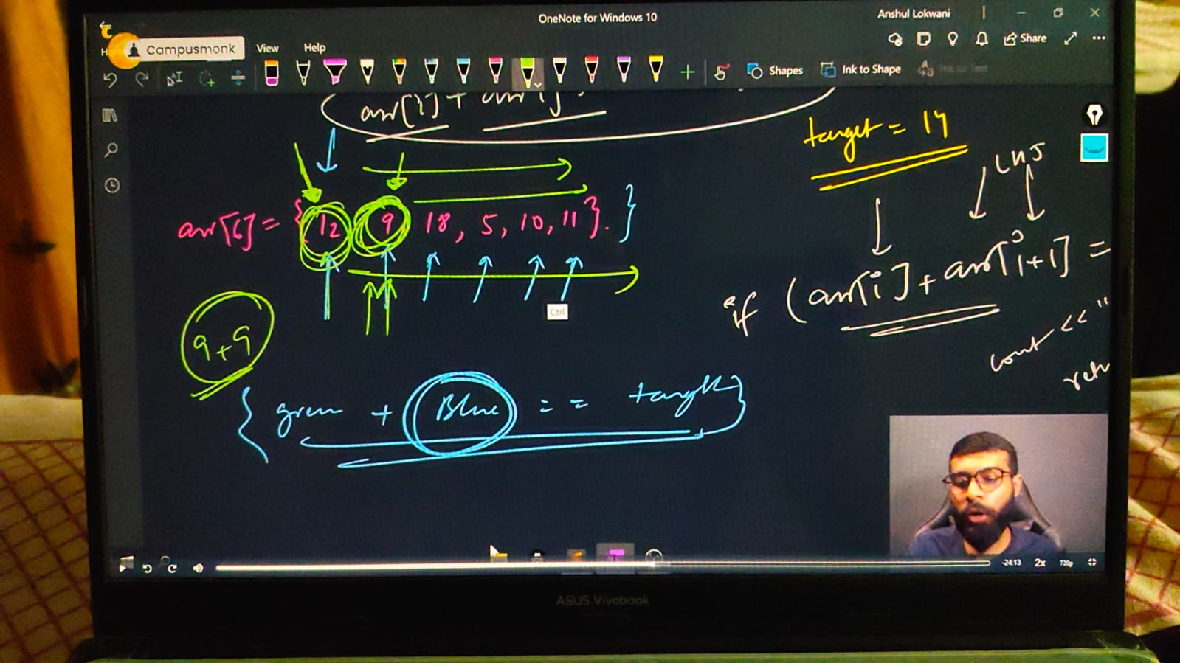

#include <iostream>

using namespace std;

int main()

{

    int n;

    cout << "mention the array size you want" << endl;

    cin >> n;

    int arr[n];

    cout << "Enter the array elements going to print - " << endl;

    for (int i = 0; i < n; i++)

    {

        cin >> arr[i];

    }

    cout << "So, the entered array is - " << endl;

    for (int i = 0; i < n; i++)

    {

        cout << arr[i] << " ";

    }

    cout << endl;

    int target;

    cout << "WHat value you want to target - " << endl;

    cin >> target;

    for (int i = 0; i < n; i++)

    {

        for (int j = i+1; j < n; j++)

        {

            if (arr[i] + arr[j] == target)

            {

                cout << "Got the target and elementts are  - " << arr[i] << " " << arr[j] << endl;

                return 0;

            }

        }

    }

    cout << "Not found the targetby array elements";

}

/* o/p -

mention the array size you want

5

Enter the array elements going to print -

56 89 12 45 78

So, the entered array is -

56 89 12 45 78

WHat value you want to target -

57

Got the target and elementts are  - 12 45

____________ ____________

mention the array size you want

5

Enter the array elements going to print -

89 56 32 21 54

So, the entered array is -

89 56 32 21 54

WHat value you want to target -

78

Not found the targetby array elements

*/

// ____________ ____________ ____________ ____________ ____________

**// 8) Qun - For given 2 arrays, find Union & Intersection**

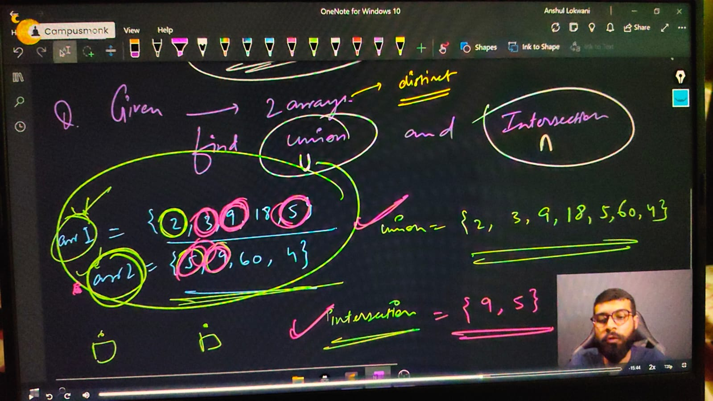

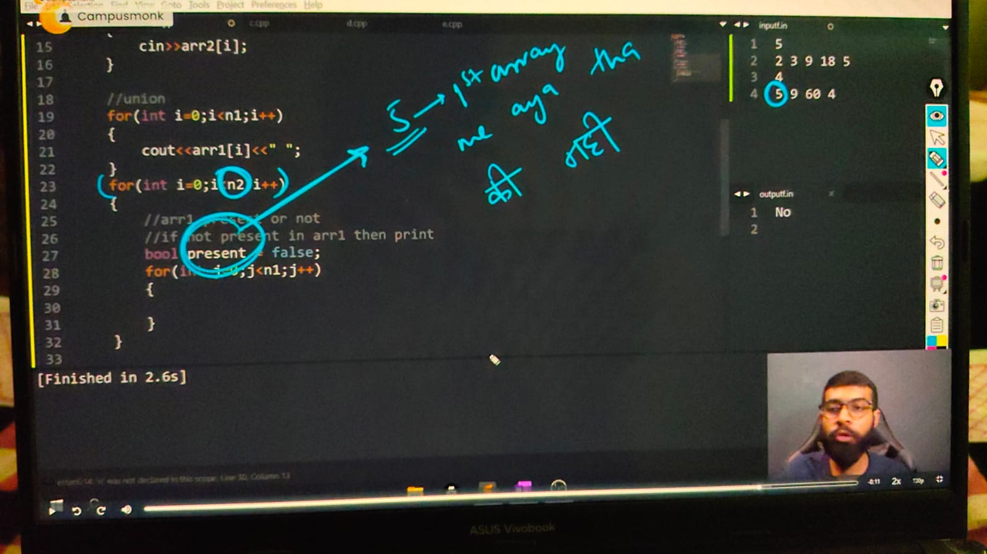

    int n1, n2;

    cout << "mention the array1 size " << endl;

    cin >> n1;

    cout << "mention the array2 size respectively" << endl;

    cin >> n2;

    int arr1[n1];

    int arr2[n2];

    cout << "Enter the array1 elements going to print - " << endl;

    for (int i = 0; i < n1; i++)

    {

        cin >> arr1[i];

    }

    cout << endl;

    cout << "and similarly Enter the array2 elements going to print - " << endl;

    for (int i = 0; i < n2; i++)

    {

        cin >> arr2[i];

    }

    cout << endl;

    // For union -

    for (int i = 0; i < n1; i++)

    {

        cout << arr1[i] << " ";

    }

    for (int i = 0; i < n2; i++)

    {

        // in arr1 check for present or not

        // if not present in arr1 then print

        bool present = false; // prsent is uses for 1st waale array me aaya he ya nahi

        for (int j = 0; j < n1; j++)

        {

            if (arr2[i] == arr1[j])

            {

                present = true;

            }

        }

        if (present == false)

        {

            cout << arr2[i] << " ";

        }

    }

    cout<<endl;

    // Intersection -

    for (int i = 0; i < n1; i++)

    {

        for (int j = 0; j < n2; j++)

        {

            if (arr1[i] == arr2[j])

            {

                cout << arr1[i] << " ";

            }

        }

    }

    cout << endl;

mention the array1 size

5

mention the array2 size respectively

2 3 9 18 5

Enter the array1 elements going to print -

4

and similarly Enter the array2 elements going to print -

5 9 60 4

2 3 9 18 5 4

9 5

// ____________ ____________ ____________ ____________ ____________

**// 9) Qun - Find majority element if any.**

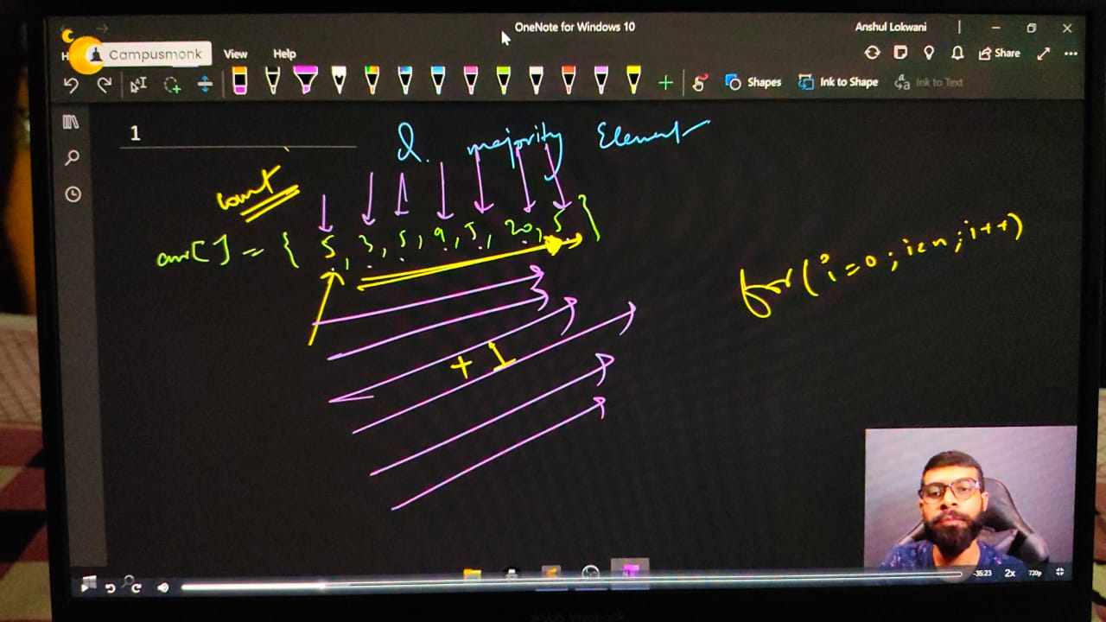

/*Note - majority elekent is given by > size of array/2

Majority Element  > {(Size of Array)/2} Ex. = arr[] = {5,3,5,9,5,18,5}

Majority element 1 hi ho skta h kyuki aadhe se jyadqa baar ek single element available he.

*/

// int n;

// cout<<"mention the array size you want"<<endl;

// cin>>n;

// int arr[n];

// cout<<"Enter the array elements going to print - "<<endl;

// for (int i = 0; i < n; i++)

// {

//     cin>>arr[i];

// }

// cout<<"So, the entered array is - "<<endl;

// for (int i = 0; i < n; i++)

// {

//     cout<<arr[i]<<" ";

// }

// cout<<endl;

// // CHekcing for majority element -

// for (int i = 0; i < n; i++)

// {

//     int count = 0;

//     for (int j = 0; j < n; j++)

//     {

//         if (arr[i]==arr[j])

//         {

//             count++;

//         }

//     }

//     if (count>n/2)

//     {

//         cout<<arr[i]<<endl;

//         return 0;

//     }

// }

// cout<<"Sorry, No Majjority Eleelment found dude"<<endl;

/*

mention the array size you want

7

Enter the array elements going to print -

5 3 5 9 5 20 5

So, the entered array is -

5 3 5 9 5 20 5

5

*/

// ____________ ____________

/*

**Method - 2**

Majority candidate can done by sorting the array because after this middle element will be the majority element.

Agr sorting ke baad middle element majority element nhi hua to phr koi sa nhi ho skta

*/

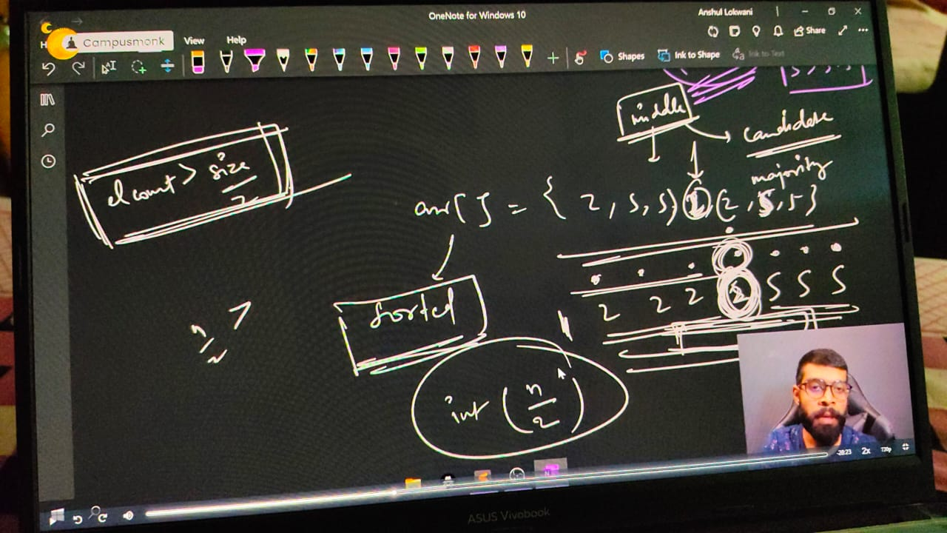

// int n;

// cout<<"mention the array size you want"<<endl;

// cin>>n;

// int arr[n];

// cout<<"Enter the array elements going to print - "<<endl;

// for (int i = 0; i < n; i++)

// {

//     cin>>arr[i];

// }

// cout<<endl;

// // CHekcing for majority element -

// sort(arr, arr+n);

// int expectedcandidate = arr[n/2];

// int count = 0;

// for (int i = 0; i < n; i++)

// {

//     if (arr[i]==expectedcandidate)

//     {

//         count++;

//     }

// }

//     if (count>n/2)

//     {

//         cout<<"The Majority candidarte is - "<<expectedcandidate<<endl;

//     }

//     else

// {

//     cout<<"No Majority element availabe";

// }

/* o/p -

mention the array size you want

7

Enter the array elements going to print -

5 3 5 9 5 18 5

The Majority candidarte is – 5

*/

// ____________ ____________ ____________ ____________ ____________

**// 10) Rotating array concept -**

**// 10.1)Right Rotation - Rotate each eleemnt by one in th eRight side**

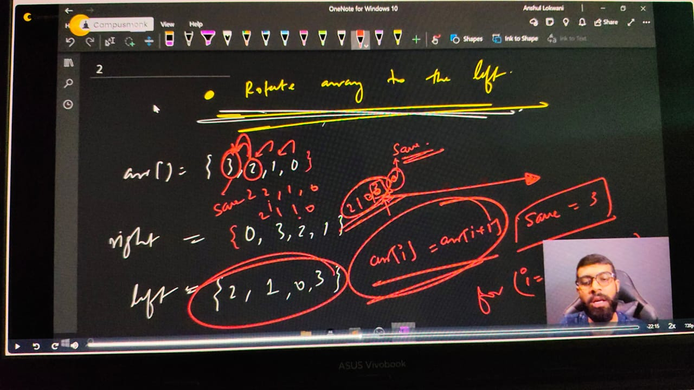

// int n;

//     cout << "Array Size: ";

//     cin >> n;

//     int arr[n];

//     cout << "Array Values:\n";

//     for (int i = 0; i < n; i++) {

//         cin >> arr[i];

//     }

//     cout << "Your array is: ";

//     for (int i = 0; i < n; i++) {

//         cout << arr[i] << " ";

//     }

//     cout << endl;

//     // Right Rotation Logic

//     int save = arr[n - 1]; // Save the last element

//     for (int i = n - 1; i > 0; i--) {

//         arr[i] = arr[i - 1]; // Shift all elements right

//     }

//     arr[0] = save; // Put last element at the front

//     cout << "Hence, the new Right Rotated Array is: ";

//     for (int i = 0; i < n; i++) {

//         cout << arr[i] << " ";

//     }

//     cout << endl;

//     return 0;

/*

Array Size: 5

Array Values:

1 2 3 4 5

Your array is: 1 2 3 4 5

Hence, the new Right Rotated Array is: 5 1 2 3 4

*/

**// 10.1)Left Rotation - Rotate each eleemnt by one in th eleft side**

    // int n;

    // cout<<"Array SIze"<<endl;

    // cin>>n;

    // int arr[n];

    // cout<<"Array Values"<<endl;

    // for (int i = 0; i < n; i++)

    // {

    //     cin>>arr[i];

    // }

    // cout<<"your array is - ";

    // for (int i = 0; i < n; i++)

    // {

    //     cout<<arr[i]<<" ";

    // }

    // cout<<endl;

    // // For Left Rotation -

    // int save = arr[0];

    // for (int i = 0; i < n; i++)

    // {

    //     arr[i] = arr[i+1];

    // }

    // arr[n-1] = save;

    // cout<<"Hence, the new Left Rotated Array is -  ";

    // for (int i = 0; i < n; i++)

    // {

    //     cout<<arr[i]<<" ";

    // }

/*

Array SIze

4

Array Values

3 2 1 0

your array is - 3 2 1 0

Hence, the new Left Rotated Array is -  2 1 0 3

*/

// ____________ ____________

**//10.3)  WHat if wants to rotate lefyt three times.**

    // int n;

    // cout<<"Array SIze"<<endl;

    // cin>>n;

    // int arr[n];

    // cout<<"Array Values"<<endl;

    // for (int i = 0; i < n; i++)

    // {

    //     cin>>arr[i];

    // }

    // cout<<"your array is - ";

    // for (int i = 0; i < n; i++)

    // {

    //     cout<<arr[i]<<" ";

    // }

    // cout<<endl;

    // // For Left Rotation -

    // int save = arr[0];

    // for (int i = 0; i < n; i++)

    // {

    //     arr[i] = arr[i+1];

    // }

    // arr[n-1] = save;

    // cout<<"After 1st rotation "<<endl;

    // for (int i = 0; i < n; i++)

    // {

    //     cout<<arr[i]<<" ";

    // }

    // cout<<endl;

    // // For 2nd left rotation -

    // int save1 = arr[0];

    // for (int i = 0; i < n; i++)

    // {

    //     arr[i] = arr[i+1];

    // }

    // arr[n-1] = save1;

    // cout<<"After 2nd rotation "<<endl;

    // for (int i = 0; i < n; i++)

    // {

    //     cout<<arr[i]<<" ";

    // }

    // cout<<endl;

    // // For 3rd left rotation -

    // int save3 = arr[0];

    // for (int i = 0; i < n; i++)

    // {

    //     arr[i] = arr[i+1];

    // }

    // arr[n-1] = save3;

    // cout<<"After 3rd rotation "<<endl;

    // for (int i = 0; i < n; i++)

    // {

    //     cout<<arr[i]<<" ";

    // }

    // cout<<endl;

    // cout<<"Hence, the new Left Rotated Array is -  ";

    // for (int i = 0; i < n; i++)

    // {

    //     cout<<arr[i]<<" ";

    // }

/*

Array SIze

5

Array Values

1 2 3 4 5

your array is - 1 2 3 4 5

After 1st rotation

2 3 4 5 1

After 2nd rotation

3 4 5 1 2

After 3rd rotation

4 5 1 2 3

Hence, the new Left Rotated Array is -  4 5 1 2 3

*/

// ____________ ____________

**// Using function can be done very easily -**

/*

#include <bits/stdc++.h>

using namespace std;

void left_rotate(int arr[], int n)

{

    int save = arr[0];

    for (int i = 0; i < n-1; i++)

    {

        arr[i] = arr[i+1];

    }

    arr[n-1] = save;

}

int main()

{

    int n;

    cout<<"Array Size"<<endl;

    cin>>n;

    int arr[n];

    cout<<"Array Elements - "<<endl;

    for (int i = 0; i < n; i++)

    {

        cin>>arr[i];

    }

    cout<<"So, your entered array is - "<<endl;

    for (int i = 0; i < n; i++)

    {

        cout<<arr[i]<<" ";

    }

    cout<<endl;

    left_rotate(arr,n);

    left_rotate(arr,n);

    left_rotate(arr,n);

    cout<<"So, the new rotated array is - "<<endl;

    for (int i = 0; i < n; i++)

    {

        cout<<arr[i]<<" ";

    }

*/

/*

Array Size

5

Array Elements -

1 2 3 4 5

So, your entered array is -

1 2 3 4 5

So, the new rotated array is -

4 5 1 2 3

*/

// ____________ ____________

**// Similarly for k times as per the need -**

// void left_rotate(int arr[], int n)

// {

//     int save = arr[0];

//     for (int i = 0; i < n-1; i++)

//     {

//         arr[i] = arr[i+1];

//     }

//     arr[n-1] = save;

// }

// int main()

// {

//     int n;

//     cout<<"Array Size"<<endl;

//     cin>>n;

//     int arr[n];

//     cout<<"Array Elements - "<<endl;

//     for (int i = 0; i < n; i++)

//     {

//         cin>>arr[i];

//     }

//     cout<<"So, your entered array is - "<<endl;

//     for (int i = 0; i < n; i++)

//     {

//         cout<<arr[i]<<" ";

//     }

//     cout<<endl;

//     int k;

//     cout<<"how many times you want to rotate this "<<endl;

//     cin>>k;

//     for (int i = 0; i < k; i++)

//     {

//         left_rotate(arr,n);

//     }

//     cout<<"So, the new rotated array is - "<<endl;

//     for (int i = 0; i < n; i++)

//     {

//         cout<<arr[i]<<" ";

//     }

// /*

// Array Size

// 5

// Array Elements -

// 1 2 3 4 5

// So, your entered array is -

// 1 2 3 4 5

// how many times you want to rotate this

// 4

// So, the new rotated array is -

// 5 1 2 3 4

// */

// }

**// ____________ ____________ ____________ ____________ ____________ ____________ ____________ ____________ ____________ ____________ ____________**

**// Subarray - Array ka koi sa bhi element and in continuos way too. must be either alone or in continuos way'**

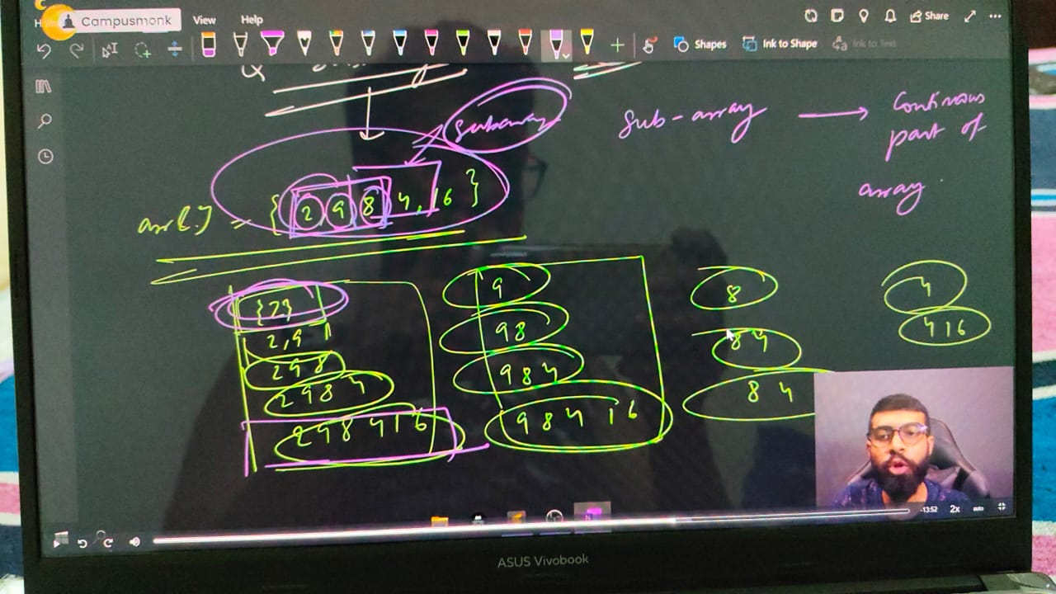

**// Qun - If target found using subarray sum then put yes otherwise leave it with no.**

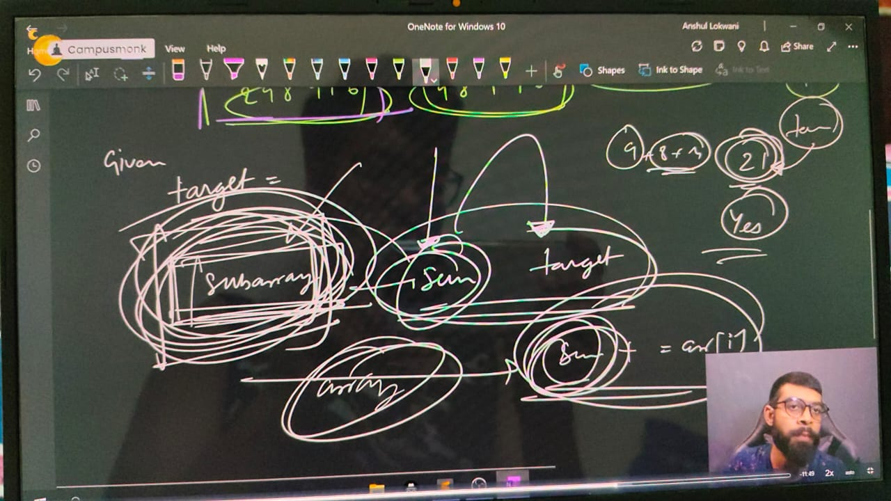

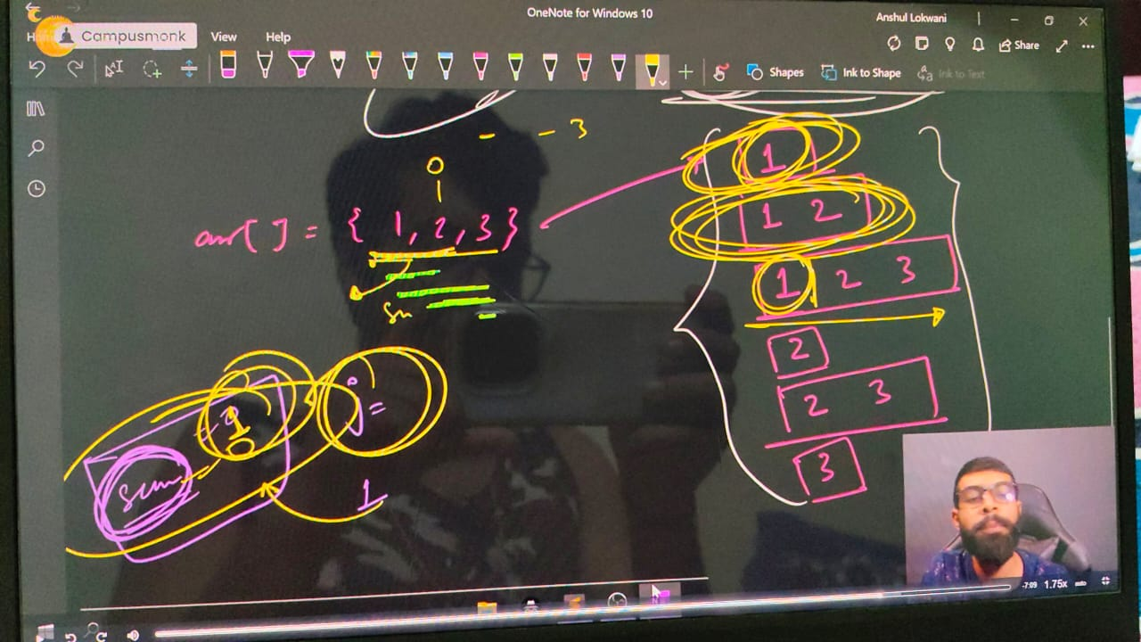

    int n;

    cout<<"Array Size"<<endl;

    cin>>n;

    int arr[n];

    cout<<"Array Elements - "<<endl;

    for (int i = 0; i < n; i++)

    {

        cin>>arr[i];

    }

    cout<<"So, your entered array is - "<<endl;

    for (int i = 0; i < n; i++)

    {

        cout<<arr[i]<<" ";

    }

    cout<<endl;

    int target;

    cout<<"Now press thye Target ELement - "<<endl;

    cin>>target;

    // For subarray sum -

    for (int i = 0; i < n; i++)

    {

        int sum=0;

        for (int j = i; j < n; j++)

        {

            sum+=arr[j];

            if (sum==target)

        {

            cout<<"Yes by using subsrray sum we got the target sum"<<endl;

            return 0;

        }

        }

    }

    cout<<"Not found"<<endl;

/*

Array Size

5

Array Elements -

1 2 3 4 5

So, your entered array is -

1 2 3 4 5

Now press thye Target ELement -

9

Yes by using subsrray sum we got the target

7

Yes by using subsrray sum we got the target sum

8

Not found

*/